

ASSET VERIFICATION AND RECORDING TOOL KIT


Plot 31, Bukoto Street
P.O Box 7657, Kampala, Uganda
+256 (0) 39 2000216/0772525235
email: cpa@cpa.ug

www.cpa.com

August to September 2026

VERIFICATION DETAILS

NAME OF THE REGION: | GREATER MASAKA
SUB-REGION:
Name of Local Government | MASAKA CITY
VERIFIER PARTICULARS
Full name | NANTUME PENNINAH/NASSALI VICTORIA K
Contact/ email and Telephone | 0760349649/0704321431
Supervisor/ Sub team leader
Name | KALYOWA LAWRENCE
Contact | 0774106047
Date of submission

HEALTH CENTRES
INFORMANT INTERVIEW/DISCUSSION GUIDE (INCHARGE OR RESPONSIBLE PERSON)

Name of Health Centre: NYENDO HEALTH CENTRE III

1a | Does the Facility have a record of all assets provided under UgIFT.  (Obtain a record and verify if it has the costs and numbers supplied | Yes
1b | If Not ask how many were supplied and when.

2 | How does this facility Maintain (repair/service/replace) the assets provided under Ugift

They get funds from different organizations

3 | Does the facility take regular record about functionality/ or breakdown of the assets provided? | Yes

4 | How has the UgIFT support helped in service delivery in the area, any issues, challenges and any recommendations for better program implementation.

Challenges
They don’t have enough staffs
Some of the equipments came incomplete

Recommendations
Most staffs are needed
But all are happy on what ugift gave them

PROCEED TO VERIFICATION AFTER THIS DISCUSSION

Health centre checklist

NAME OF LG: MASAKA CITY NAME OF HEALTH FACILITY: NYENDO HEALTH CENTRE III

Equipment/ Item | Department | Asset Number | Item  Description | Life in Months | Tag Number ( engrave no.) | Date Of Purchase | Date Placed In Service | Recoverable cost | Cost | Acc Dep Cost | Net Book Value | Ytd Deprn | Equipment status | Remarks
B.P. Machine, Digital | OPD |  | They received 2 white in colour |  | Not engraved | 2024/2025 | 2024/2025 |  |  |  |  |  | Good | Functional
B.P. Machine (Aneroid wall mounted) | OPD |  | They received 2 but not verified |  |  | 2024/2025 | 2024/2025 |  |  |  |  |  | Good | Functional
Autoclave 20 Liters.,Duo Operated
Bowl, Kick | MOH |  | It was 1 with stainless steel |  | Not engraved | 2024/2025 | 2024/2025 |  |  |  |  |  | Good | Functional
Bowl Stand | MOH |  | They were 2 stainless steel |  | Not engraved | 2024/2025 | 2024/2025 |  |  |  |  |  | Good | Functional
Counting chamber Neubauer- Improved | MOH |  | They received 2 white in colour |  | Not engraved | 2024/2025 | 2024/2025 |  |  |  |  |  | Good | Functional
Cupboard Steel, Lockable | OPD |  | They received 2 grey in colour |  | Not engraved | 2024/2025 | 2024/2025 |  |  |  |  |  | Good | Functional
Drip Stand | WARD |  | Received 8 white in colour |  | Not engraved | 2024/2025 | 2024/2025 |  |  |  |  |  | Good | Functional
ESR Stand | MOH |  | Received 1 with sedimentation tubes |  | Not engraved | 2024/2025 | 2024/2025 |  |  |  |  |  | Good | Functional
Examination Couch | MOH |  | They are 2 metallic |  | Not engraved | 2024/2025 | 2024/2025 |  |  |  |  |  | Good | Functional
Examination light,LED | MOH |  | They are 2 but not verified |  |  | 2024/2025 | 2024/2025 |  |  |  |  |  | Good | Functional
Glucometer | MOH |  | They are 2 white in colour |  | Not engraved | 2024/2025 | 2024/2025 |  |  |  |  |  | Good | Functional
Haemoglobin Meter, Digital | MOH |  | They are 2 but not verified |  | Not engraved | 2024/2025 | 2024/2025 |  |  |  |  |  | Good | Functional
Height Meter | MOH |  | It was 1 but not verified |  |  | 2024/2025 | 2024/2025 |  |  |  |  |  | Good | Functional
Instrument Trolley | MOH |  | It was 2 but not verified |  |  | 2024/2025 | 2024/2025 |  |  |  |  |  | Good | Functional
Microscope Binocular | LAB |  | It was 1 white in colour |  | Not engraved | 2024/2025 | 2024/2025 |  |  |  |  |  | Good | Functional
Otoscope | OPD |  | It was1 but not verified |  |  | 2024/2025 | 2024/2025 |  |  |  |  |  | Good | Functional
Patient Screen | OPD |  | They were 4 metallic blue colour |  | Not engraved | 2024/2025 | 2024/2025 |  |  |  |  |  | Good | Functional
Patient Trolley | OPD |  | It was 1 silver and black in colour with wheels |  | Not engraved | 2024/2025 | 2024/2025 |  |  |  |  |  | Good | Functional
Refrigerator, Basic | MOH |  | It was 1 grey in colour |  | Not engraved | 2024/2025 | 2024/2025 |  |  |  |  |  | Good | Functional
Stethoscope | MOH |  | They were four but not verified |  |  | 2024/2025 | 2024/2025 |  |  |  |  |  | Good | Functional
Stop Watch | MOH |  | They were 2 but not verified |  |  | 2024/2025 | 2024/2025 |  |  |  |  |  | Good | Functional
Stretcher | OPD |  | It was 1 with black matress |  | Not engraved | 2024/2025 | 2024/2025 |  |  |  |  |  | Good | Functional
Stove, Gas | LAB |  | It was 1 black in colour with wheels |  | Not engraved | 2024/2025 | 2024/2025 |  |  |  |  |  | Good | Functional
Weighing Scale with Height Meter, Adult | MOH |  | They were 2 white in colour height meter |  | Not engraved | 2024/2025 | 2024/2025 |  |  |  |  |  | Good | Functional
Weighing Scale, Infant | MOH |  | They were 2 but not verified |  |  | 2024/2025 | 2024/2025 |  |  |  |  |  | Good | Functional
Weighing Scale, Toddler | MOH |  | They were 2 but not verified |  |  | 2024/2025 | 2024/2025 |  |  |  |  |  | Good | Functional
Wheel Chair
Audio Visual Equipment
Medical Waste Bin | Health |  | They were 6 stainless wastebins |  | Not engraved | 2024/2025 | 2024/2025 |  |  |  |  |  | Good | Functional
Wall Clock | Health |  | They were 4 round and white |  | Not engraved | 2024/2025 | 2024/2025 |  |  |  |  |  | Good | Functional
Diagnostic Equipment Set for MCH | MOH |  | They were 2 but not verified |  |  | 2024/2025 | 2024/2025 |  |  |  |  |  | Good | Functional
Diagnostic Equipment Set for OPD | OPD |  | They were 2 but not verified |  |  | 2024/2025 | 2024/2025 |  |  |  |  |  | Good | Functional
Glassware Set, Laboratory, Basic | LAB |  | They were 2 colourless and breakable |  | Not engraved | 2024/2025 | 2024/2025 |  |  |  |  |  | Good | Functional
Hollow Ware Set, Treatment
Instrument Set, Dressing | MOH |  | They were 2 and consists scissors for kidney operation |  | Not engraved | 2024/2025 | 2024/2025 |  |  |  |  |  | Good | Functional
Instrument Set, Basic ENT | MOH |  | They were not verified |  |  | 2024/2025 | 2024/2025 |  |  |  |  |  | Good | Functional
Instrument Set, Suture
Pulse Oximeter, Hand held | MOH |  | They were 2 but not verified |  |  | 2024/2025 | 2024/2025 |  |  |  |  |  | Good | Functional
Bed, Adult Patient with Mattress | Ward |  | They received 10 beds with black mattresses |  | Not engraved | 2024/2025 | 2024/2025 |  |  |  |  |  | Good | Functional
Bed, Pediatric Patient, With Mattress | Ward |  | They received 5 beds small with black mattresses |  | Not engraved | 2024/2025 | 2024/2025 |  |  |  |  |  | Good | Functional
Bedside Locker
Cupboard, Instrument | OPD |  | It was 1 but not stainless |  | Not engraved | 2024/2025 | 2024/2025 |  |  |  |  |  | Good | Functional
Delivery Bed, Hydraulic Manual | MOH |  | It was 1 with a blue mattress |  | Not engraved | 2024/2025 | 2024/2025 |  |  |  |  |  | Good | Functional
Oxygen Therapy Apparatus, Mininum 45L cylinder | MOH |  | They were 2 oxygen therapy apparatuses |  | Not engraved | 2024/2025 | 2024/2025 |  |  |  |  |  | Good | Functional
Resuscitator Manual, Infant, with all Mask sizes | MOH |  | They were 2 but not verified |  |  | 2024/2025 | 2024/2025 |  |  |  |  |  | Good | Functional
Resuscitator Manual, Adult, with all mask sizes | MOH |  | They were 2 but not verified |  |  | 2024/2025 | 2024/2025 |  |  |  |  |  | Good | Functional
Suction Apparatus, (Electric) | MOH |  | They were 2 but not verified |  |  | 2024/2025 | 2024/2025 |  |  |  |  |  | Good | Functional
Nebulizer, Ultrasonic | MOH |  | It was 1 but not verified |  |  | 2024/2025 | 2024/2025 |  |  |  |  |  | Good | Functional
Oxygen Concentrator, Duo Flow
Bench | OPD |  | They were 4 brown in colour |  | Not engraved | 2024/2025 | 2024/2025 |  |  |  |  |  | Good | Functional
Disinfection Buckets | MOH |  | They were 6 in normal form |  | Not engraved | 2024/2025 | 2024/2025 |  |  |  |  |  | Good | Functional
Baby Cot | MOH |  | They were 5 but not verified |  |  | 2024/2025 | 2024/2025 |  |  |  |  |  | Good | Functional
Diagnostic Equipment Set for Ward | MOH |  | They were 3 but not verified |  |  | 2024/2025 | 2024/2025 |  |  |  |  |  | Good | Functional
Hollow Ware Set, Ward | MOH |  | They were 3 but not verified |  |  | 2024/2025 | 2024/2025 |  |  |  |  |  | Good | Functional
Instrument Set, Delivery | MOH |  | They were 3 still packed |  |  | 2024/2025 | 2024/2025 |  |  |  |  |  | Good | Functional
Instrument Set, Stitch Removing | MOH |  | They were 3 still packed |  |  | 2024/2025 | 2024/2025 |  |  |  |  |  | Good | Functional
MVA Kit | MOH |  | They were 4 but not verified |  |  | 2024/2025 | 2024/2025 |  |  |  |  |  | Good | Functional
Stool, Laboratory | LAB |  | It was 1 black in colour |  | Not engraved | 2024/2025 | 2024/2025 |  |  |  |  |  | Good | Functional
Penguin Sucker | MOH |  | They were 3 rubber in nature |  | Not engraved | 2024/2025 | 2024/2025 |  |  |  |  |  | Good | Functional
Fetoscope, Dopplar | MOH |  | They were 2 silver in nature with a round top |  |  | 2024/2025 | 2024/2025 |  |  |  |  |  | Good | Functional
Bubble CPAP | MOH |  | They were 2 but not verified |  |  | 2024/2025 | 2024/2025 |  |  |  |  |  | Good | Functional
Centrifuge (Electric) | MOH |  | They were 2 but not verified |  |  | 2024/2025 | 2024/2025 |  |  |  |  |  | Good | Functional
Kangaroo Mother Care Chair | MOH |  | It was 1 but broken |  |  | 2024/2025 | 2024/2025 |  |  |  |  |  | Good | Functional
Radiant Infant Warmer
Haemoglobin Meter, Sahli
Delivery Bed
Examination light
Instrument set, ENT Basic for HCIII
Bag Valve mask (Ambu Bag), Neonatal
Incubator
Office Chair | Office |  | They were 7 black in nature with wheels |  |  | 2024/2025 | 2024/2025 |  |  |  |  |  | Good | Functional
Desk | OPD |  | They were 3 brown in colour |  |  | 2024/2025 | 2024/2025 |  |  |  |  |  | Good | Functional
Filing Cabinet | OPD |  | They were 2 but not verified |  |  | 2024/2025 | 2024/2025 |  |  |  |  |  | Good | Functional
Non Residential Buildings
Residential Buildings | Building |  | It was 1 with different rooms |  |  | 2024/2025 | 2024/2025 |  |  |  |  |  | Good | Functional

Cabin Stool Glassware Weighing scale
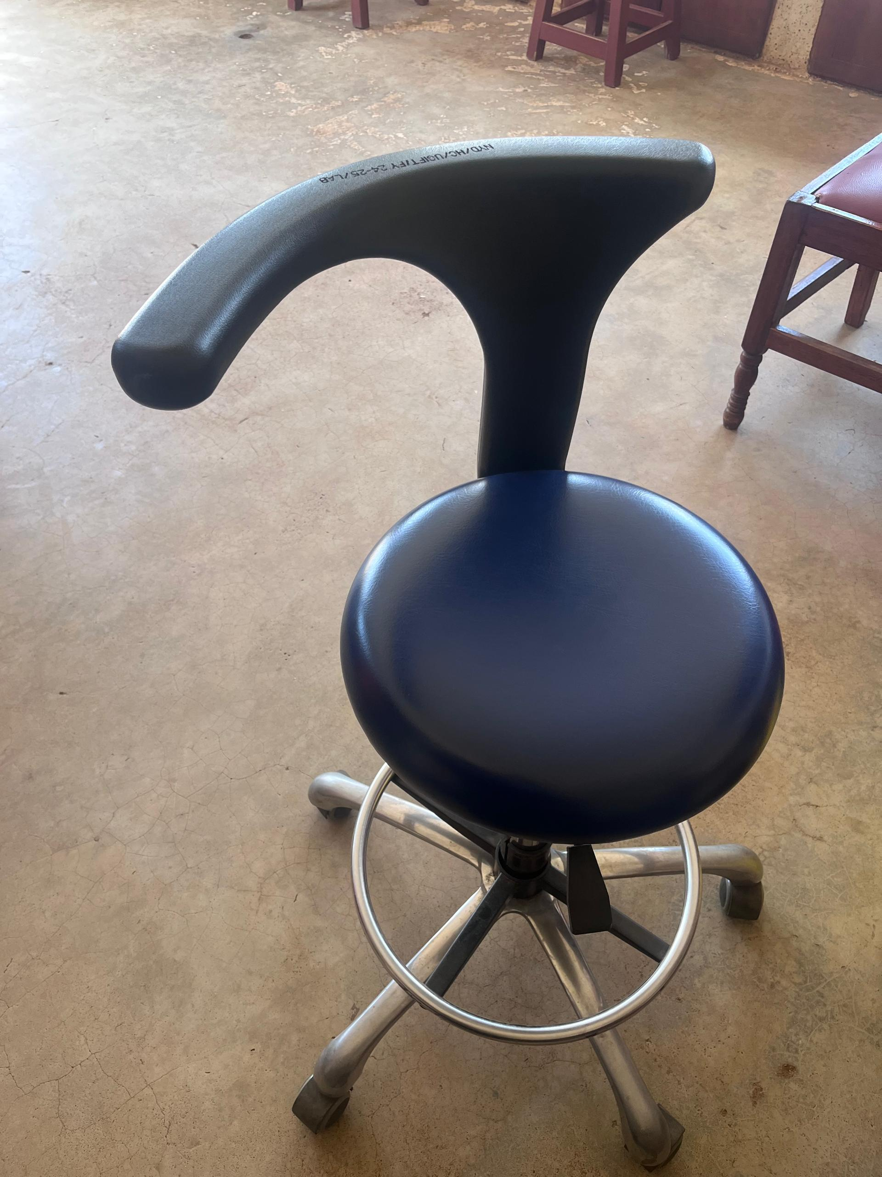
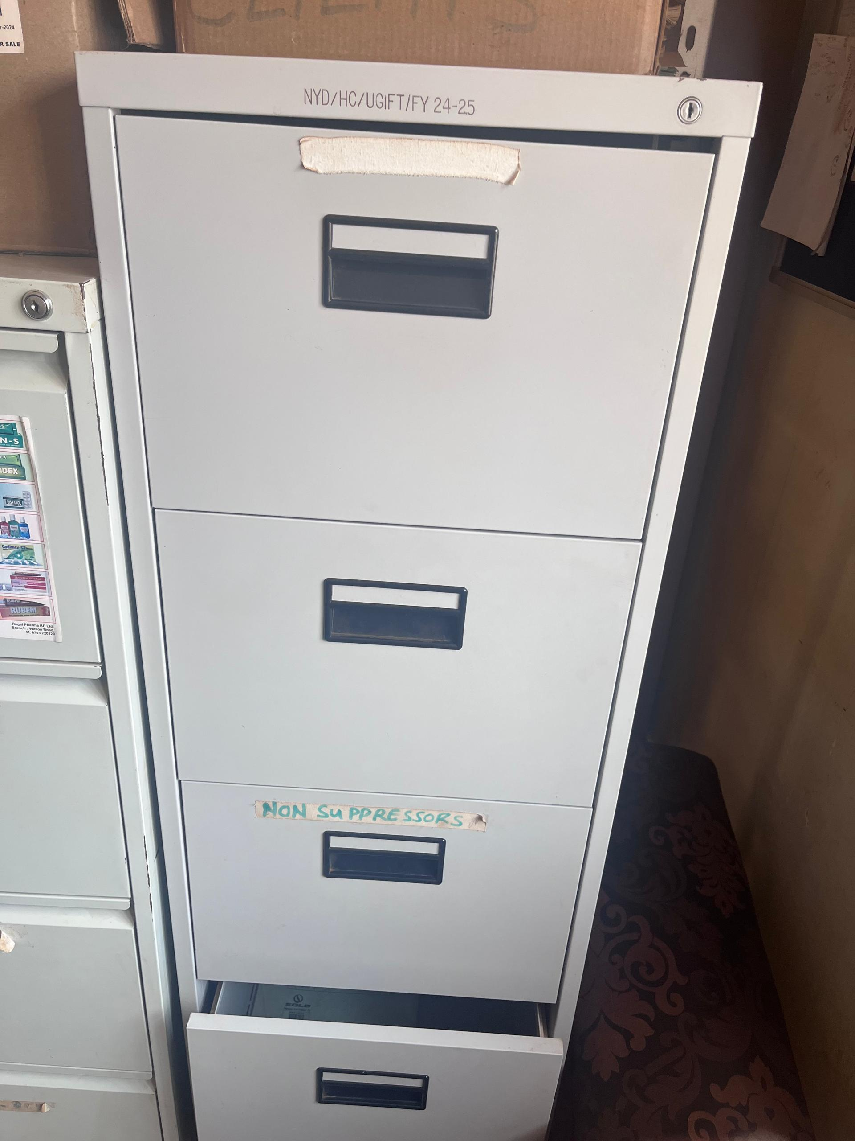
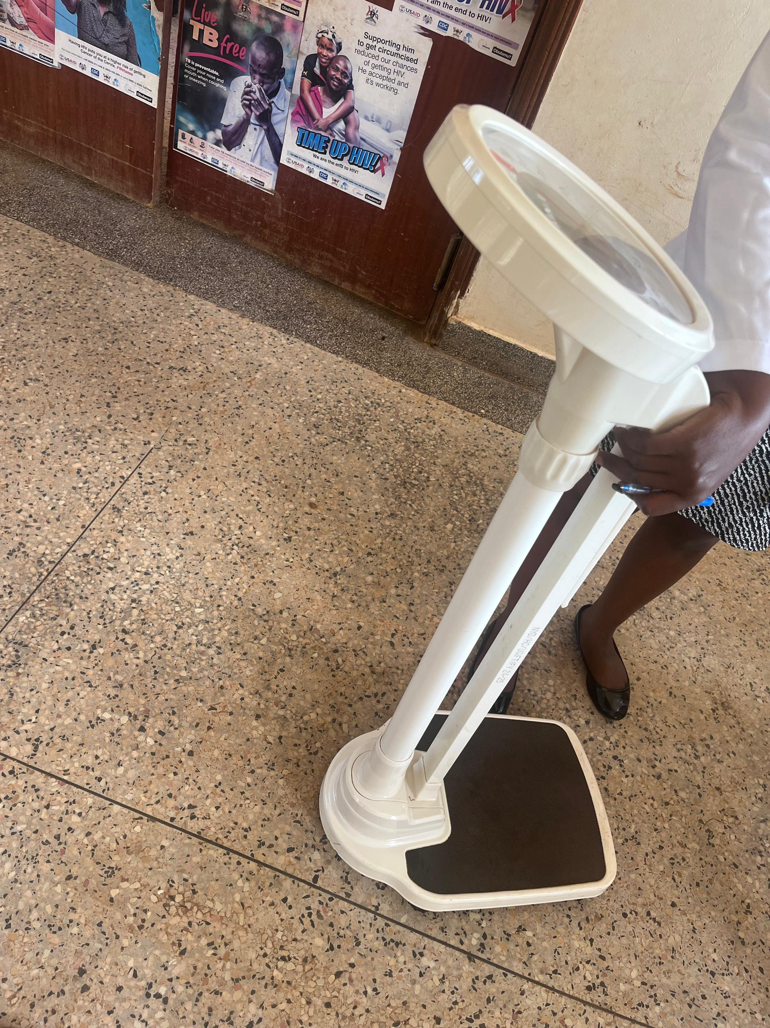
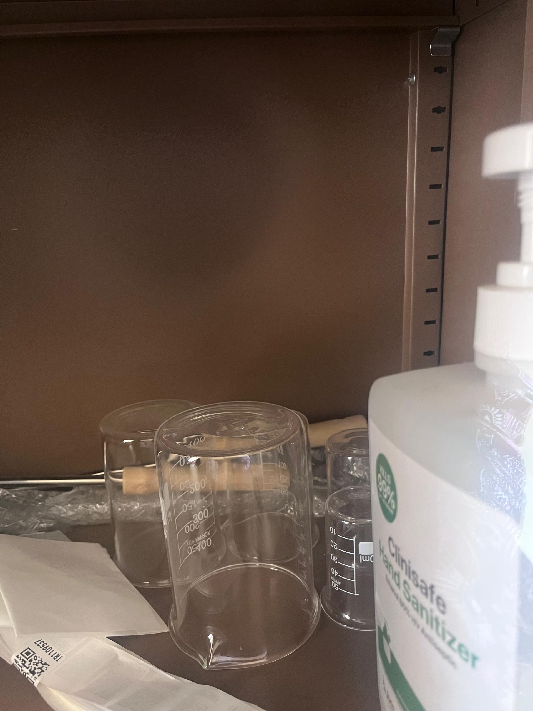

Kangaroo chair Delivery bed
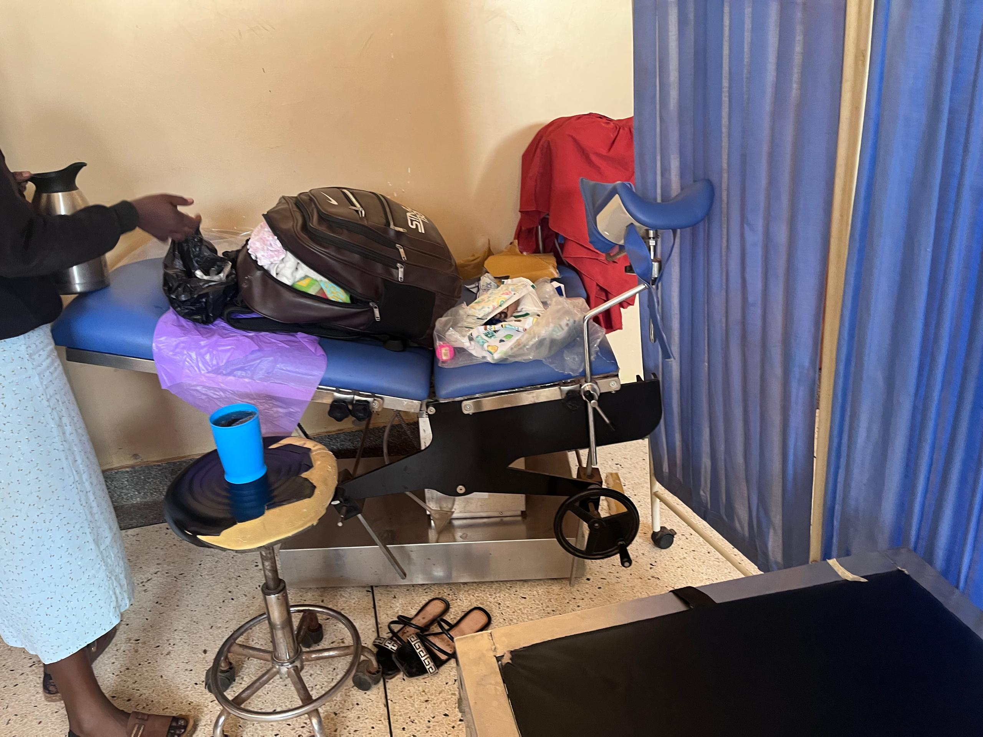
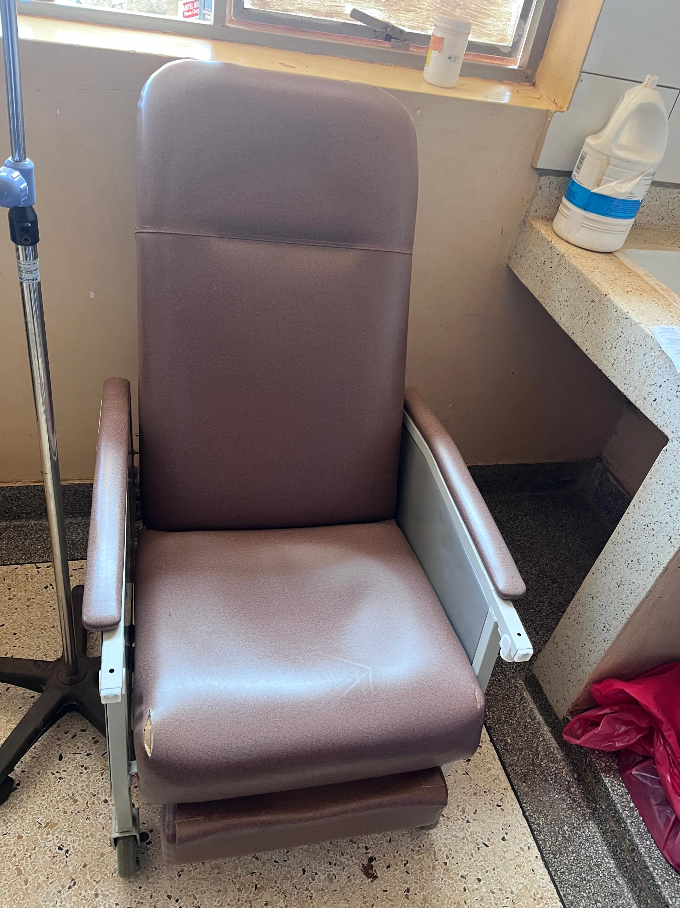

SCHOOL VERIFICATION CHECKLIST

SCHOOL INTERVIEW/DISCUSSION GUIDE

Name of school: ………………………………………………………………………………..

1a | Does the Facility have a record of all assets provided under UgIFT.  (Obtain a record and verify if it has the costs and numbers supplied
1b | If Not ask how many were supplied and when.

2 | How does this facility Maintain (repair/service/replace) the assets provided under Ugift

3 | Does the facility take regular record about functionality/ or breakdown of the assets provided?  Nonfunctional/ working, and reasons for non-functionality.

4 | How has the UgIFT support helped in service delivery in the area, any issues, challenges and any recommendations for better program implementation.

PROCEED TO VERIFICATION AFTER THIS DISCUSSION

SCHOOL FURNITURE
(School Desks, Office chairs, Laboratory stools, Book shelves)

Name of LG………………………………………………………………… Name of SCHOOL………………………………………………………………………………

Equipment/ Item | Department | Asset Number | Item  Description | Life in Months | Tag Number ( engrave no.) | Date Of Pur | Date Placed In Service | Recoverable cost | Cost | Acc Dep Cost | Net Book Value | Ytd Deprn | Equipment status | Remarks

ICT ITEMS TO VERIFY
(Desktop Computer, Server Processor, Network Switch 24 Port, Multipurpose Printer, UPS, Projector, Air Conditioners, Server, CCTV Camera)

Name of LG…………………………………………………………………………… Name of SCHOOL………………………….………………………………………

Equipment/ Item | Department | Asset Number | Item  Description | Life in Months | Tag Number ( engrave no.) | Date Of Pur | Date Placed In Service | Recoverable cost | Cost | Acc Dep Cost | Net Book Value | Ytd Deprn | Equipment status | Remarks

BUILDINGS TO VERIFY
(Non- Residential and Residential, Kitchen, Toilets/Pit latrine Water tanks, Fences etc.)

Name of LG…………………………………………………………………………… Name of SCHOOL………………………….………………………………………

Equipment/ Item | Department | Asset Number | Item  Description | Life in Months | Tag Number ( engrave no.) | Date Of Pur | Date Placed In Service | Recoverable cost | Cost | Acc Dep Cost | Net Book Value | Ytd Deprn | Equipment status | Remarks

